**Report of CSCI572 HW4 Solr Exercise**

1. Steps of what I have done

* I read all the documents carefully and found that I didn’t need to use Ubuntu because I have a Mac
* Then I followed the document “Instructions for Installing Solr” to install solr on my Mac. First download the “Solr-7.5.0.zip” and then use command line “unzip –q solr-7.5.0.zip” to unzip it and use “cd solr-7.5.0” to get into its directory. Then I use bin/solr start to start the solr server. And I finished the three examples in the instructions.
* I followed the document “Indexing HTML files Solr” to index files which I download from google drive. Created a new core using command bin/solr create –c myexample.
* Edit the managed-schema file and add the following 2 parameters as follow:



* I used command $bin/post –c myexample –filetypes html HTML/files/ to index html files in Solr.
* Then I can open the admin UI via <http://localhost:8983/solr/>
* Search on google on how to start Apache within Mac.
* Git clone php package
* put solr-php-client on my directory “/Library/WebServer/Documents”
* modify the given php code, and I use Bootstrap4 to get the beautiful UI. Also put it within the directory above
* In Intellij IDEA I created a maven project and import the JSoup dependency and writed the java code. The java code read all the outgoing links in HTML pages and finally output a edgelist file which could be used to calculate the pagerank in the next step.
* Open my mac command line and input python the get the python environment and then import nextworkx library. Then read the edgelist file generated before and get the pagerank file.
* I used several parameters in python as below:



* Copy the pagerank file to the core directory in Solr.
* Edit the managed-schema file by adding the following codes:



* Then reload Solr from Solr admin UI and it works well

1. Explanations on why some pages have higher PageRank values.

That is because there are lots of other pages have links pointing to these pages. The more incomings links to these pages, the higher PageRank they will get.

1. Flow for query “LA Lakers” using screenshots

·Initial page

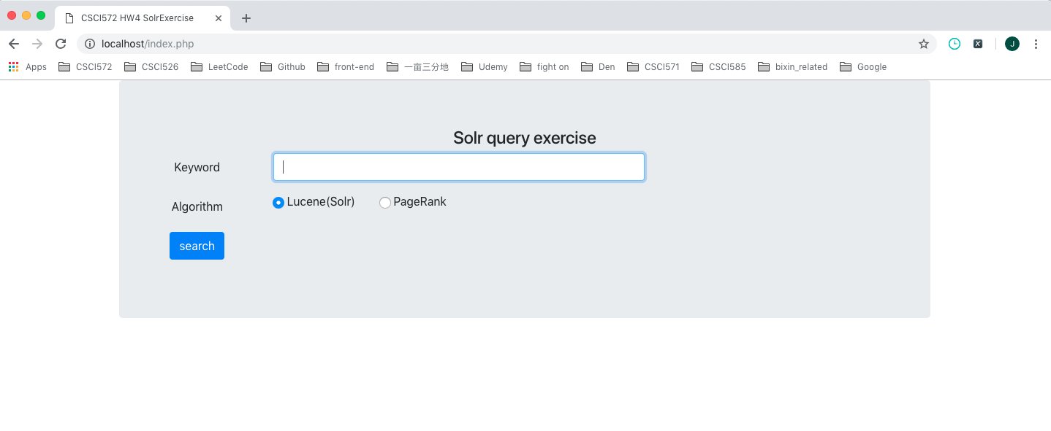

·enter query “LA Lakers” in input box

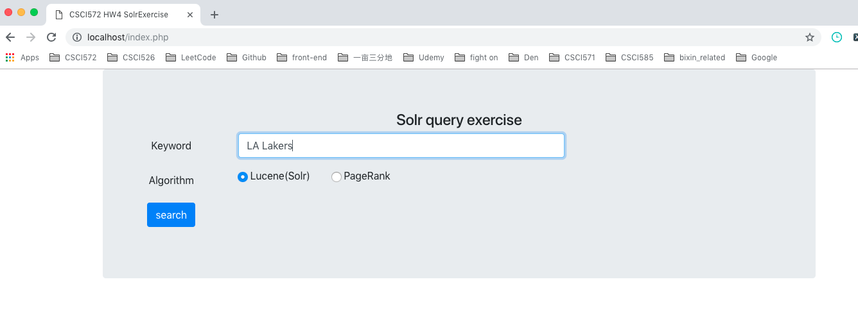

·results for using Lucene

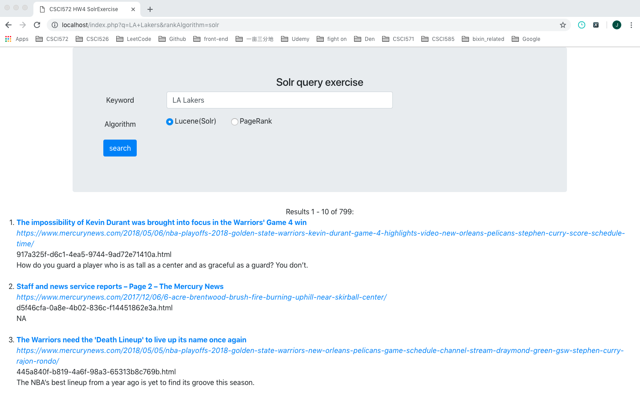

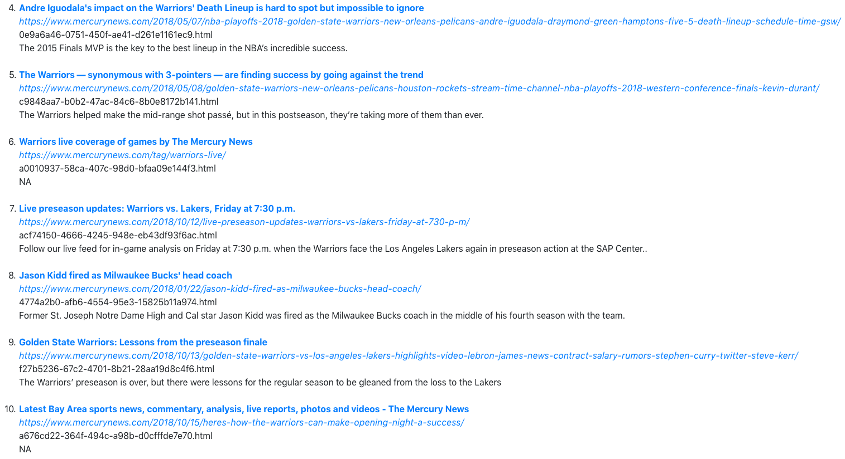

·results for using PageRank

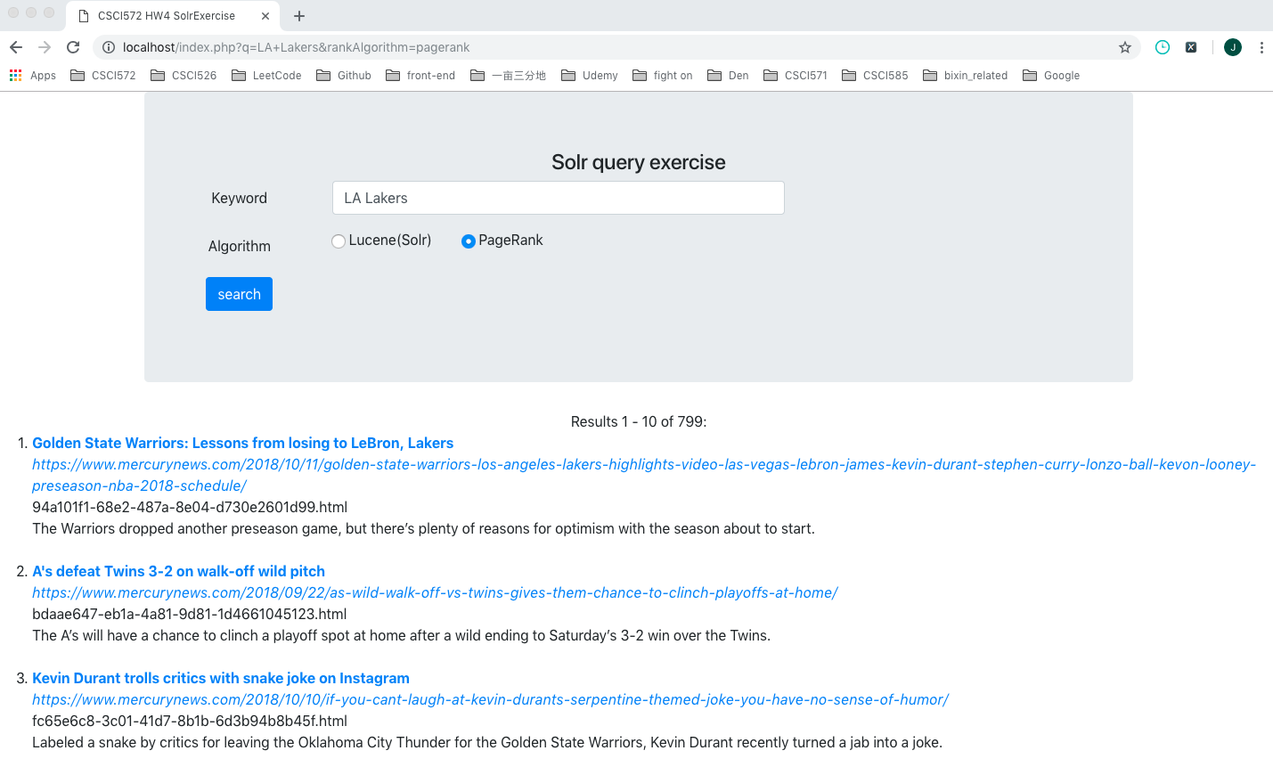

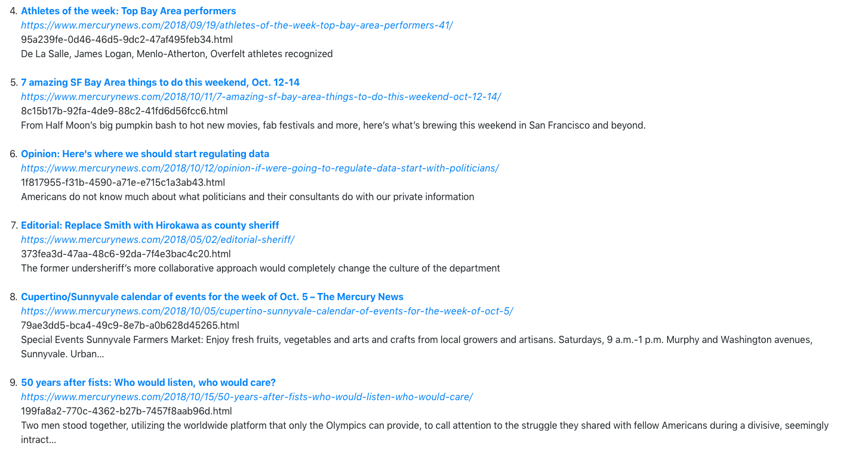



·click on one of the link

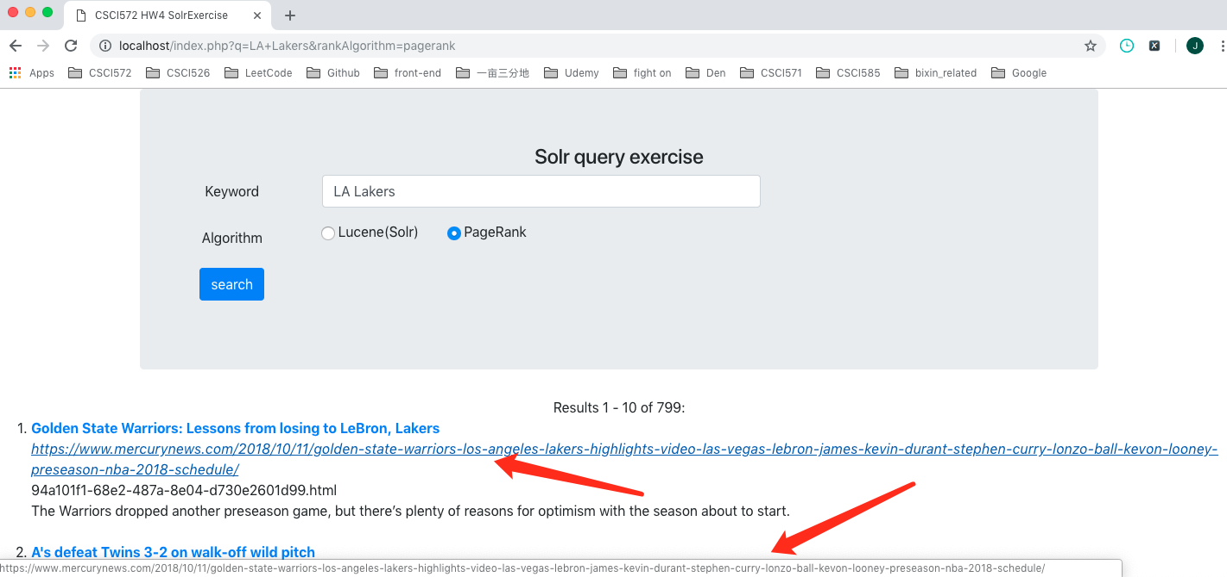



1. Table of top ten results produced by both ranking methods

·query “Donald Trump”

|  |  |
| --- | --- |
| Donald Trump | |
| Lucene | PageRank |
| <https://www.mercurynews.com/2018/09/28/kimberly-guilfoyle-didnt-join-donald-trump-jr-s-twitter-attacks-on-christine-blasey-fords-credibility/> | [*https://www.mercurynews.com/2014/01/22/celebrating-dr-kings-accomplishments/*](https://www.mercurynews.com/2014/01/22/celebrating-dr-kings-accomplishments/) |
| |  |  |  |  |  |  | | --- | --- | --- | --- | --- | --- | | https://www.mercurynews.com/tag/celebrity-politics/page/2/ |  |  |  |  |  | | [*https://www.mercurynews.com/2018/02/20/h-1b-visas-how-the-trump-administration-is-freaking-people-out/*](https://www.mercurynews.com/2018/02/20/h-1b-visas-how-the-trump-administration-is-freaking-people-out/) |
| [*https://www.mercurynews.com/2016/08/31/who-is-kevin-macdonald-alt-right-californian-retweeted-by-donald-trump-jr/*](https://www.mercurynews.com/2016/08/31/who-is-kevin-macdonald-alt-right-californian-retweeted-by-donald-trump-jr/) | [*https://www.mercurynews.com/2018/10/14/trump-on-friction-with-mattis-hes-a-good-guy-but-sort-of-a-democrat/*](https://www.mercurynews.com/2018/10/14/trump-on-friction-with-mattis-hes-a-good-guy-but-sort-of-a-democrat/) |
| [*https://www.mercurynews.com/2018/10/05/ivanka-trump-self-proclaimed-advocate-for-women-is-fine-with-brett-kavanaughs-confirmation-report-says/*](https://www.mercurynews.com/2018/10/05/ivanka-trump-self-proclaimed-advocate-for-women-is-fine-with-brett-kavanaughs-confirmation-report-says/) | [*https://www.mercurynews.com/2018/09/04/kaepernick-nike-backlash-fierce-but-they-arent-getting-the-worst-of-it/*](https://www.mercurynews.com/2018/09/04/kaepernick-nike-backlash-fierce-but-they-arent-getting-the-worst-of-it/) |
| [*https://www.mercurynews.com/2018/07/18/did-queen-elizabeth-wage-brooch-warfare-against-donald-trump/*](https://www.mercurynews.com/2018/07/18/did-queen-elizabeth-wage-brooch-warfare-against-donald-trump/) | [*https://www.mercurynews.com/2018/01/02/how-east-palo-alto-shed-its-crime-rep-and-built-a-new-path-forward/*](https://www.mercurynews.com/2018/01/02/how-east-palo-alto-shed-its-crime-rep-and-built-a-new-path-forward/) |
| [*https://www.mercurynews.com/2018/09/24/more-ivanka-trump-complicity-first-daughter-stays-silent-on-brett-kavanaugh-controversy/*](https://www.mercurynews.com/2018/09/24/more-ivanka-trump-complicity-first-daughter-stays-silent-on-brett-kavanaugh-controversy/) | [*https://www.mercurynews.com/2018/06/23/opinion-the-world-cup-is-coming-but-fifa-makes-me-nervous/*](https://www.mercurynews.com/2018/06/23/opinion-the-world-cup-is-coming-but-fifa-makes-me-nervous/) |
| [*https://www.mercurynews.com/2018/08/28/political-cartoons-donald-trump-and-the-john-mccain-tributes/*](https://www.mercurynews.com/2018/08/28/political-cartoons-donald-trump-and-the-john-mccain-tributes/) | [*https://www.mercurynews.com/2018/05/27/robinson-dark-branding-trump-knows-words-dont-just-describe-reality-they-shape-it/*](https://www.mercurynews.com/2018/05/27/robinson-dark-branding-trump-knows-words-dont-just-describe-reality-they-shape-it/) |
| [*https://www.mercurynews.com/2018/08/30/political-cartoons-donald-trump-blasts-google/*](https://www.mercurynews.com/2018/08/30/political-cartoons-donald-trump-blasts-google/) | [*https://www.mercurynews.com/2018/09/26/apple-google-twitter-execs-to-talk-privacy-before-senate-panel/*](https://www.mercurynews.com/2018/09/26/apple-google-twitter-execs-to-talk-privacy-before-senate-panel/) |
| [*https://www.mercurynews.com/2018/09/21/opinion-evangelicals-puzzling-devotion-to-donald-trump/*](https://www.mercurynews.com/2018/09/21/opinion-evangelicals-puzzling-devotion-to-donald-trump/) | [*https://www.mercurynews.com/2018/09/18/reports-suspended-uc-berkeley-professor-retires-plans-to-sue/*](https://www.mercurynews.com/2018/09/18/reports-suspended-uc-berkeley-professor-retires-plans-to-sue/) |
| [*https://www.mercurynews.com/2018/09/21/opinion-evangelicals-puzzling-devotion-to-donald-trump/*](https://www.mercurynews.com/2018/09/21/opinion-evangelicals-puzzling-devotion-to-donald-trump/) | |  |  |  |  |  | | --- | --- | --- | --- | --- | | *https://www.mercurynews.com/tag/social-networks/* |  |  |  |  | |

·query “LA Lakers”

|  |  |
| --- | --- |
| LA Lakers | |
| Lucene | PageRank |
| [*https://www.mercurynews.com/2018/05/06/nba-playoffs-2018-golden-state-warriors-kevin-durant-game-4-highlights-video-new-orleans-pelicans-stephen-curry-score-schedule-time/*](https://www.mercurynews.com/2018/05/06/nba-playoffs-2018-golden-state-warriors-kevin-durant-game-4-highlights-video-new-orleans-pelicans-stephen-curry-score-schedule-time/) | [*https://www.mercurynews.com/2018/10/11/golden-state-warriors-los-angeles-lakers-highlights-video-las-vegas-lebron-james-kevin-durant-stephen-curry-lonzo-ball-kevon-looney-preseason-nba-2018-schedule/*](https://www.mercurynews.com/2018/10/11/golden-state-warriors-los-angeles-lakers-highlights-video-las-vegas-lebron-james-kevin-durant-stephen-curry-lonzo-ball-kevon-looney-preseason-nba-2018-schedule/) |
| [*https://www.mercurynews.com/2017/12/06/6-acre-brentwood-brush-fire-burning-uphill-near-skirball-center/*](https://www.mercurynews.com/2017/12/06/6-acre-brentwood-brush-fire-burning-uphill-near-skirball-center/) | [*https://www.mercurynews.com/2018/09/22/as-wild-walk-off-vs-twins-gives-them-chance-to-clinch-playoffs-at-home/*](https://www.mercurynews.com/2018/09/22/as-wild-walk-off-vs-twins-gives-them-chance-to-clinch-playoffs-at-home/) |
| [*https://www.mercurynews.com/2018/05/05/nba-playoffs-2018-golden-state-warriors-new-orleans-pelicans-game-schedule-channel-stream-draymond-green-gsw-stephen-curry-rajon-rondo/*](https://www.mercurynews.com/2018/05/05/nba-playoffs-2018-golden-state-warriors-new-orleans-pelicans-game-schedule-channel-stream-draymond-green-gsw-stephen-curry-rajon-rondo/) | [*https://www.mercurynews.com/2018/10/10/if-you-cant-laugh-at-kevin-durants-serpentine-themed-joke-you-have-no-sense-of-humor/*](https://www.mercurynews.com/2018/10/10/if-you-cant-laugh-at-kevin-durants-serpentine-themed-joke-you-have-no-sense-of-humor/) |
| [*https://www.mercurynews.com/2018/05/07/nba-playoffs-2018-golden-state-warriors-new-orleans-pelicans-andre-iguodala-draymond-green-hamptons-five-5-death-lineup-schedule-time-gsw/*](https://www.mercurynews.com/2018/05/07/nba-playoffs-2018-golden-state-warriors-new-orleans-pelicans-andre-iguodala-draymond-green-hamptons-five-5-death-lineup-schedule-time-gsw/) | [*https://www.mercurynews.com/2018/09/19/athletes-of-the-week-top-bay-area-performers-41/*](https://www.mercurynews.com/2018/09/19/athletes-of-the-week-top-bay-area-performers-41/) |
| [*https://www.mercurynews.com/2018/05/08/golden-state-warriors-new-orleans-pelicans-houston-rockets-stream-time-channel-nba-playoffs-2018-western-conference-finals-kevin-durant/*](https://www.mercurynews.com/2018/05/08/golden-state-warriors-new-orleans-pelicans-houston-rockets-stream-time-channel-nba-playoffs-2018-western-conference-finals-kevin-durant/) | [*https://www.mercurynews.com/2018/10/11/7-amazing-sf-bay-area-things-to-do-this-weekend-oct-12-14/*](https://www.mercurynews.com/2018/10/11/7-amazing-sf-bay-area-things-to-do-this-weekend-oct-12-14/) |
| |  |  |  |  |  | | --- | --- | --- | --- | --- | | *https://www.mercurynews.com/tag/warriors-live/* |  |  |  |  | | [*https://www.mercurynews.com/2018/10/12/opinion-if-were-going-to-regulate-data-start-with-politicians/*](https://www.mercurynews.com/2018/10/12/opinion-if-were-going-to-regulate-data-start-with-politicians/) |
| [*https://www.mercurynews.com/2018/10/12/live-preseason-updates-warriors-vs-lakers-friday-at-730-p-m/*](https://www.mercurynews.com/2018/10/12/live-preseason-updates-warriors-vs-lakers-friday-at-730-p-m/) | [*https://www.mercurynews.com/2018/05/02/editorial-sheriff/*](https://www.mercurynews.com/2018/05/02/editorial-sheriff/) |
| [*https://www.mercurynews.com/2018/01/22/jason-kidd-fired-as-milwaukee-bucks-head-coach/*](https://www.mercurynews.com/2018/01/22/jason-kidd-fired-as-milwaukee-bucks-head-coach/) | [*https://www.mercurynews.com/2018/10/05/cupertino-sunnyvale-calendar-of-events-for-the-week-of-oct-5/*](https://www.mercurynews.com/2018/10/05/cupertino-sunnyvale-calendar-of-events-for-the-week-of-oct-5/) |
| [*https://www.mercurynews.com/2018/10/13/golden-state-warriors-vs-los-angeles-lakers-highlights-video-lebron-james-news-contract-salary-rumors-stephen-curry-twitter-steve-kerr/*](https://www.mercurynews.com/2018/10/13/golden-state-warriors-vs-los-angeles-lakers-highlights-video-lebron-james-news-contract-salary-rumors-stephen-curry-twitter-steve-kerr/) | [*https://www.mercurynews.com/2018/10/15/50-years-after-fists-who-would-listen-who-would-care/*](https://www.mercurynews.com/2018/10/15/50-years-after-fists-who-would-listen-who-would-care/) |
| [*https://www.mercurynews.com/2018/10/15/heres-how-the-warriors-can-make-opening-night-a-success/*](https://www.mercurynews.com/2018/10/15/heres-how-the-warriors-can-make-opening-night-a-success/) | [*https://www.mercurynews.com/2018/10/15/dunkin-opening-next-generation-coffee-shop-in-san-carlos/*](https://www.mercurynews.com/2018/10/15/dunkin-opening-next-generation-coffee-shop-in-san-carlos/) |

·query “Star Wars”

|  |  |
| --- | --- |
| Star Wars | |
| Lucene | PageRank |
| |  |  |  |  |  | | --- | --- | --- | --- | --- | | *https://www.mercurynews.com/tag/star-wars/* |  |  |  |  | | [*https://www.mercurynews.com/2018/06/20/nba-draft-how-warriors-have-been-successful-with-recent-late-draft-picks/*](https://www.mercurynews.com/2018/06/20/nba-draft-how-warriors-have-been-successful-with-recent-late-draft-picks/) |
| [*https://www.mercurynews.com/2017/12/14/fans-line-up-for-star-wars-the-last-jedi-at-the-tech-museum/*](https://www.mercurynews.com/2017/12/14/fans-line-up-for-star-wars-the-last-jedi-at-the-tech-museum/) | [*https://www.mercurynews.com/2018/09/04/kaepernick-nike-backlash-fierce-but-they-arent-getting-the-worst-of-it/*](https://www.mercurynews.com/2018/09/04/kaepernick-nike-backlash-fierce-but-they-arent-getting-the-worst-of-it/) |
| [*https://www.mercurynews.com/2018/10/08/disneyland-star-wars-galaxys-edge-preview/*](https://www.mercurynews.com/2018/10/08/disneyland-star-wars-galaxys-edge-preview/) | [*https://www.mercurynews.com/2018/08/26/oakland-grand-lake-theaters-longtime-operator-buys-the-building-and-ensures-its-future-as-a-movie-theater/*](https://www.mercurynews.com/2018/08/26/oakland-grand-lake-theaters-longtime-operator-buys-the-building-and-ensures-its-future-as-a-movie-theater/) |
| [*https://www.mercurynews.com/2018/10/08/disneyland-star-wars-galaxys-edge-preview/*](https://www.mercurynews.com/2018/10/08/disneyland-star-wars-galaxys-edge-preview/) | [*https://www.mercurynews.com/2018/08/21/for-ariana-grande-and-pete-davidson-the-vmas-was-one-big-make-out-session/*](https://www.mercurynews.com/2018/08/21/for-ariana-grande-and-pete-davidson-the-vmas-was-one-big-make-out-session/) |
| [*http://www.ocregister.com/disneyland-will-sell-alcohol-for-the-first-time-when-star-wars-land-opens-in-2019*](http://www.ocregister.com/disneyland-will-sell-alcohol-for-the-first-time-when-star-wars-land-opens-in-2019) | [*https://www.mercurynews.com/2018/10/07/walking-dead-cast-celebrities-remember-scott-wilson/*](https://www.mercurynews.com/2018/10/07/walking-dead-cast-celebrities-remember-scott-wilson/) |
| [*https://www.mercurynews.com/2018/08/01/star-wars-filmmaker-j-j-abrams-sends-his-first-ever-tweet-heres-what-it-said/*](https://www.mercurynews.com/2018/08/01/star-wars-filmmaker-j-j-abrams-sends-his-first-ever-tweet-heres-what-it-said/) | |  |  |  |  |  |  |  |  |  |  |  | | --- | --- | --- | --- | --- | --- | --- | --- | --- | --- | --- | | *https://www.mercurynews.com/location/california/bay-area/south-bay/santa-clara-county/almaden-valley/page/3/* |  |  |  |  |  |  |  |  |  |  | |
| [*http://www.ocregister.com/disneyland-is-quietly-removing-seating-and-planters-for-star-wars-land-access*](http://www.ocregister.com/disneyland-is-quietly-removing-seating-and-planters-for-star-wars-land-access) | [*https://www.mercurynews.com/2018/08/24/if-san-jose-state-football-is-going-to-be-markedly-better-these-10-things-better-happen/*](https://www.mercurynews.com/2018/08/24/if-san-jose-state-football-is-going-to-be-markedly-better-these-10-things-better-happen/) |
| [*https://www.mercurynews.com/2018/08/22/star-wars-actress-defies-racists-with-return-to-instagram/*](https://www.mercurynews.com/2018/08/22/star-wars-actress-defies-racists-with-return-to-instagram/) | |  |  |  |  |  | | --- | --- | --- | --- | --- | | *https://www.mercurynews.com/tag/social-networks/* |  |  |  |  | |
| [*https://www.mercurynews.com/2018/10/15/17-ways-to-save-money-on-a-trip-to-disneyland/*](https://www.mercurynews.com/2018/10/15/17-ways-to-save-money-on-a-trip-to-disneyland/) | [*https://www.mercurynews.com/2018/07/16/will-debate-over-baseballs-current-defects-offers-lessons-about-other-things/*](https://www.mercurynews.com/2018/07/16/will-debate-over-baseballs-current-defects-offers-lessons-about-other-things/) |
| [*http://www.ocregister.com/disneyland-is-quietly-removing-seating-and-planters-for-star-wars-land-access*](http://www.ocregister.com/disneyland-is-quietly-removing-seating-and-planters-for-star-wars-land-access) | [*https://www.mercurynews.com/2018/09/22/as-wild-walk-off-vs-twins-gives-them-chance-to-clinch-playoffs-at-home/*](https://www.mercurynews.com/2018/09/22/as-wild-walk-off-vs-twins-gives-them-chance-to-clinch-playoffs-at-home/) |

·query “Lebron James”

|  |  |
| --- | --- |
| Lebron James | |
| Lucene | PageRank |
| |  |  |  |  |  |  | | --- | --- | --- | --- | --- | --- | | *https://www.mercurynews.com/tag/lebron-james/page/2/* |  |  |  |  |  | | [*https://www.mercurynews.com/2014/01/22/celebrating-dr-kings-accomplishments/*](https://www.mercurynews.com/2014/01/22/celebrating-dr-kings-accomplishments/) |
| |  |  |  |  |  | | --- | --- | --- | --- | --- | | *https://www.mercurynews.com/tag/lebron-james/* |  |  |  |  | | [*https://www.mercurynews.com/2018/09/04/kaepernick-nike-backlash-fierce-but-they-arent-getting-the-worst-of-it/*](https://www.mercurynews.com/2018/09/04/kaepernick-nike-backlash-fierce-but-they-arent-getting-the-worst-of-it/) |
| [*https://www.mercurynews.com/2018/08/06/lebron-james-son-bronny-headed-to-crossroads-reports-say/*](https://www.mercurynews.com/2018/08/06/lebron-james-son-bronny-headed-to-crossroads-reports-say/) | [*https://www.mercurynews.com/2018/01/02/how-east-palo-alto-shed-its-crime-rep-and-built-a-new-path-forward/*](https://www.mercurynews.com/2018/01/02/how-east-palo-alto-shed-its-crime-rep-and-built-a-new-path-forward/) |
| |  |  |  |  |  |  | | --- | --- | --- | --- | --- | --- | | *https://www.mercurynews.com/tag/cleveland-cavaliers/* |  |  |  |  |  | | [*https://www.mercurynews.com/2018/10/11/golden-state-warriors-los-angeles-lakers-highlights-video-las-vegas-lebron-james-kevin-durant-stephen-curry-lonzo-ball-kevon-looney-preseason-nba-2018-schedule/*](https://www.mercurynews.com/2018/10/11/golden-state-warriors-los-angeles-lakers-highlights-video-las-vegas-lebron-james-kevin-durant-stephen-curry-lonzo-ball-kevon-looney-preseason-nba-2018-schedule/) |
| [*https://www.mercurynews.com/2018/08/04/president-trump-rips-lebron-james-says-i-like-mike/*](https://www.mercurynews.com/2018/08/04/president-trump-rips-lebron-james-says-i-like-mike/) | [*https://www.mercurynews.com/2018/01/02/man-found-fatally-shot-in-east-oakland-hills-identified/*](https://www.mercurynews.com/2018/01/02/man-found-fatally-shot-in-east-oakland-hills-identified/) |
| [*https://www.mercurynews.com/2018/05/30/nba-finals-2018-golden-sta-warriors-lebron-james-cleveland-cavaliers-game-1-time-schedule-roster-stephen-curry/*](https://www.mercurynews.com/2018/05/30/nba-finals-2018-golden-sta-warriors-lebron-james-cleveland-cavaliers-game-1-time-schedule-roster-stephen-curry/) | [*https://www.mercurynews.com/2007/08/31/best-bets-for-fall-reading/*](https://www.mercurynews.com/2007/08/31/best-bets-for-fall-reading/) |
| [*https://www.mercurynews.com/2018/08/04/president-trump-rips-lebron-james-says-i-like-mike/*](https://www.mercurynews.com/2018/08/04/president-trump-rips-lebron-james-says-i-like-mike/) | [*https://www.mercurynews.com/2018/08/24/twitter-ceo-faces-deadline-on-testifying-about-gop-bias-claims-report/*](https://www.mercurynews.com/2018/08/24/twitter-ceo-faces-deadline-on-testifying-about-gop-bias-claims-report/) |
| [*https://www.mercurynews.com/2018/10/01/did-javale-mcgee-upstage-lebron-james-in-their-laker-debuts/*](https://www.mercurynews.com/2018/10/01/did-javale-mcgee-upstage-lebron-james-in-their-laker-debuts/) | [*https://www.mercurynews.com/2018/09/10/uc-berkeley-loses-legal-fight-over-crispr-patents/*](https://www.mercurynews.com/2018/09/10/uc-berkeley-loses-legal-fight-over-crispr-patents/) |
| [*https://www.mercurynews.com/2018/10/10/report-lebron-james-wont-face-warriors-in-san-jose-friday/*](https://www.mercurynews.com/2018/10/10/report-lebron-james-wont-face-warriors-in-san-jose-friday/) | [*https://www.mercurynews.com/2018/10/10/if-you-cant-laugh-at-kevin-durants-serpentine-themed-joke-you-have-no-sense-of-humor/*](https://www.mercurynews.com/2018/10/10/if-you-cant-laugh-at-kevin-durants-serpentine-themed-joke-you-have-no-sense-of-humor/) |
| [*https://www.mercurynews.com/2018/05/30/in-lebron-james-vs-warriors-the-nba-finals-get-strong-dose-of-best-ever-debate/*](https://www.mercurynews.com/2018/05/30/in-lebron-james-vs-warriors-the-nba-finals-get-strong-dose-of-best-ever-debate/) | [*https://www.mercurynews.com/2018/09/27/he-set-up-trump-tower-meeting-now-he-wants-to-clear-his-name/*](https://www.mercurynews.com/2018/09/27/he-set-up-trump-tower-meeting-now-he-wants-to-clear-his-name/) |

·query “2018 World Cup”

|  |  |
| --- | --- |
| 2018 World Cup | |
| Lucene | PageRank |
| [*https://www.mercurynews.com/2018/04/26/high-school-baseball-monta-vista-beats-lynbrook-3-1/*](https://www.mercurynews.com/2018/04/26/high-school-baseball-monta-vista-beats-lynbrook-3-1/) | [*https://www.mercurynews.com/2018/10/09/animals-in-wrong-places-gators-black-bears-and-giraffes-oh-my/*](https://www.mercurynews.com/2018/10/09/animals-in-wrong-places-gators-black-bears-and-giraffes-oh-my/) |
| |  |  |  |  |  |  | | --- | --- | --- | --- | --- | --- | | *https://www.mercurynews.com/tag/world-cup/page/2/* |  |  |  |  |  | | [*https://www.mercurynews.com/2018/06/20/nba-draft-how-warriors-have-been-successful-with-recent-late-draft-picks/*](https://www.mercurynews.com/2018/06/20/nba-draft-how-warriors-have-been-successful-with-recent-late-draft-picks/) |
| |  |  |  |  |  | | --- | --- | --- | --- | --- | | *https://www.mercurynews.com/tag/soccer/page/3/* |  |  |  |  | | [*https://www.mercurynews.com/2014/01/22/celebrating-dr-kings-accomplishments/*](https://www.mercurynews.com/2014/01/22/celebrating-dr-kings-accomplishments/) |
| |  |  |  |  |  | | --- | --- | --- | --- | --- | | *https://www.mercurynews.com/tag/world-cup/* |  |  |  |  | | [*https://www.mercurynews.com/2018/02/20/h-1b-visas-how-the-trump-administration-is-freaking-people-out/*](https://www.mercurynews.com/2018/02/20/h-1b-visas-how-the-trump-administration-is-freaking-people-out/) |
| [*https://www.mercurynews.com/2018/09/30/us-looking-for-another-historic-comeback-at-the-ryder-cup/*](https://www.mercurynews.com/2018/09/30/us-looking-for-another-historic-comeback-at-the-ryder-cup/) | [*https://www.mercurynews.com/2018/09/26/milpitas-community-briefs-for-the-week-of-sept-28/*](https://www.mercurynews.com/2018/09/26/milpitas-community-briefs-for-the-week-of-sept-28/) |
| [*https://www.mercurynews.com/2018/07/13/world-cup-final-what-time-do-france-and-croatia-play-for-soccer-title/*](https://www.mercurynews.com/2018/07/13/world-cup-final-what-time-do-france-and-croatia-play-for-soccer-title/) | [*https://www.mercurynews.com/2018/09/12/editorial-elect-keller-cummings-natarajan-to-bart-board/*](https://www.mercurynews.com/2018/09/12/editorial-elect-keller-cummings-natarajan-to-bart-board/) |
| [*https://www.mercurynews.com/2018/07/16/world-cup-rewind-why-this-brit-and-many-like-him-are-bloody-angry-and-still-hurt/*](https://www.mercurynews.com/2018/07/16/world-cup-rewind-why-this-brit-and-many-like-him-are-bloody-angry-and-still-hurt/) | [*https://www.mercurynews.com/2018/10/14/trump-on-friction-with-mattis-hes-a-good-guy-but-sort-of-a-democrat/*](https://www.mercurynews.com/2018/10/14/trump-on-friction-with-mattis-hes-a-good-guy-but-sort-of-a-democrat/) |
| [*https://www.mercurynews.com/2018/05/11/startup-world-cup-competition-decides-best-of-28-startups-from-around-the-globe/*](https://www.mercurynews.com/2018/05/11/startup-world-cup-competition-decides-best-of-28-startups-from-around-the-globe/) | [*https://www.mercurynews.com/2018/09/04/kaepernick-nike-backlash-fierce-but-they-arent-getting-the-worst-of-it/*](https://www.mercurynews.com/2018/09/04/kaepernick-nike-backlash-fierce-but-they-arent-getting-the-worst-of-it/) |
| |  |  |  |  |  | | --- | --- | --- | --- | --- | | *https://www.mercurynews.com/tag/sailing/* |  |  |  |  | | [*https://www.mercurynews.com/2018/01/02/how-east-palo-alto-shed-its-crime-rep-and-built-a-new-path-forward/*](https://www.mercurynews.com/2018/01/02/how-east-palo-alto-shed-its-crime-rep-and-built-a-new-path-forward/) |
| [*https://www.mercurynews.com/2018/09/30/us-looking-for-another-historic-comeback-at-the-ryder-cup/*](https://www.mercurynews.com/2018/09/30/us-looking-for-another-historic-comeback-at-the-ryder-cup/) | [*https://www.mercurynews.com/2018/06/23/opinion-the-world-cup-is-coming-but-fifa-makes-me-nervous/*](https://www.mercurynews.com/2018/06/23/opinion-the-world-cup-is-coming-but-fifa-makes-me-nervous/) |

·query “North Korea”

|  |  |
| --- | --- |
| North Korea | |
| Lucene | PageRank |
| [*http://wirehub-digitalfirstmedia-com.go-vip.co/two-koreas-agree-to-end-war-this-year-pursue-denuclearization*](http://wirehub-digitalfirstmedia-com.go-vip.co/two-koreas-agree-to-end-war-this-year-pursue-denuclearization) | [*https://www.mercurynews.com/2018/06/20/nba-draft-how-warriors-have-been-successful-with-recent-late-draft-picks/*](https://www.mercurynews.com/2018/06/20/nba-draft-how-warriors-have-been-successful-with-recent-late-draft-picks/) |
| [*https://www.mercurynews.com/2018/10/02/seoul-north-korea-estimated-to-have-20-60-nuclear-weapons/*](https://www.mercurynews.com/2018/10/02/seoul-north-korea-estimated-to-have-20-60-nuclear-weapons/) | [*https://www.mercurynews.com/2018/09/04/kaepernick-nike-backlash-fierce-but-they-arent-getting-the-worst-of-it/*](https://www.mercurynews.com/2018/09/04/kaepernick-nike-backlash-fierce-but-they-arent-getting-the-worst-of-it/) |
| [*https://www.mercurynews.com/2018/09/26/rubin-four-reasons-why-declaring-peace-on-korean-peninsula-is-a-bad-idea/*](https://www.mercurynews.com/2018/09/26/rubin-four-reasons-why-declaring-peace-on-korean-peninsula-is-a-bad-idea/) | [*https://www.mercurynews.com/2018/06/23/opinion-the-world-cup-is-coming-but-fifa-makes-me-nervous/*](https://www.mercurynews.com/2018/06/23/opinion-the-world-cup-is-coming-but-fifa-makes-me-nervous/) |
| [*https://www.mercurynews.com/2018/05/14/trudy-rubin-hold-the-trump-nobel-korea-talks-will-be-a-long-haul/*](https://www.mercurynews.com/2018/05/14/trudy-rubin-hold-the-trump-nobel-korea-talks-will-be-a-long-haul/) | [*https://www.mercurynews.com/2018/09/07/pipeline-company-found-guilty-in-2015-california-oil-spill/*](https://www.mercurynews.com/2018/09/07/pipeline-company-found-guilty-in-2015-california-oil-spill/) |
| [*https://www.mercurynews.com/2017/08/29/tivo-apple-among-gainers-as-investors-shake-off-north-korea-fears/*](https://www.mercurynews.com/2017/08/29/tivo-apple-among-gainers-as-investors-shake-off-north-korea-fears/) | [*https://www.mercurynews.com/2018/05/27/robinson-dark-branding-trump-knows-words-dont-just-describe-reality-they-shape-it/*](https://www.mercurynews.com/2018/05/27/robinson-dark-branding-trump-knows-words-dont-just-describe-reality-they-shape-it/) |
| [*https://www.mercurynews.com/2018/04/19/hanson-will-syrian-airstrikes-take-us-down-slippery-slope-of-more-involvement-in-the-middle-east/*](https://www.mercurynews.com/2018/04/19/hanson-will-syrian-airstrikes-take-us-down-slippery-slope-of-more-involvement-in-the-middle-east/) | [*https://www.mercurynews.com/2018/06/14/clendaniel-suicide/*](https://www.mercurynews.com/2018/06/14/clendaniel-suicide/) |
| [*https://www.mercurynews.com/2018/08/01/pence-welcomes-return-of-presumed-korean-war-dead/*](https://www.mercurynews.com/2018/08/01/pence-welcomes-return-of-presumed-korean-war-dead/) | [*https://www.mercurynews.com/2018/10/04/mountain-view-city-allows-marijuana-retailers/*](https://www.mercurynews.com/2018/10/04/mountain-view-city-allows-marijuana-retailers/) |
| [*https://www.mercurynews.com/2018/09/26/rubin-four-reasons-why-declaring-peace-on-korean-peninsula-is-a-bad-idea/*](https://www.mercurynews.com/2018/09/26/rubin-four-reasons-why-declaring-peace-on-korean-peninsula-is-a-bad-idea/) | |  |  |  |  |  |  |  |  |  |  |  | | --- | --- | --- | --- | --- | --- | --- | --- | --- | --- | --- | | *https://www.mercurynews.com/location/california/bay-area/south-bay/santa-clara-county/downtown-san-jose/page/2/* |  |  |  |  |  |  |  |  |  |  | |
| [*https://www.mercurynews.com/2018/06/18/trudy-rubin-the-nauseating-flattery-trump-lavished-on-this-mass-murderer/*](https://www.mercurynews.com/2018/06/18/trudy-rubin-the-nauseating-flattery-trump-lavished-on-this-mass-murderer/) | [*https://www.mercurynews.com/2018/06/06/multi-million-dollar-prostitution-ring-stretched-from-kansas-to-bay-area-feds-say/*](https://www.mercurynews.com/2018/06/06/multi-million-dollar-prostitution-ring-stretched-from-kansas-to-bay-area-feds-say/) |
| [*https://www.mercurynews.com/2018/06/24/the-southern-poverty-law-center-has-lost-all-credibility/*](https://www.mercurynews.com/2018/06/24/the-southern-poverty-law-center-has-lost-all-credibility/) | [*https://www.mercurynews.com/2018/01/02/fremont-skaters-switch-to-pairs-is-paying-off/*](https://www.mercurynews.com/2018/01/02/fremont-skaters-switch-to-pairs-is-paying-off/) |

·query “Hurricane Florence”

|  |  |
| --- | --- |
| Hurricane Florence | |
| Lucene | PageRank |
| [*https://www.mercurynews.com/2018/09/14/how-hurricane-florence-is-affecting-bay-area-travelers-and-what-they-need-to-know/*](https://www.mercurynews.com/2018/09/14/how-hurricane-florence-is-affecting-bay-area-travelers-and-what-they-need-to-know/) | [*https://www.mercurynews.com/2018/08/21/for-ariana-grande-and-pete-davidson-the-vmas-was-one-big-make-out-session/*](https://www.mercurynews.com/2018/08/21/for-ariana-grande-and-pete-davidson-the-vmas-was-one-big-make-out-session/) |
| [*https://www.mercurynews.com/2018/09/27/beer-trending-on-social-media-after-brett-kavanaughs-references-during-testimony/*](https://www.mercurynews.com/2018/09/27/beer-trending-on-social-media-after-brett-kavanaughs-references-during-testimony/) | [*https://www.mercurynews.com/2018/10/11/7-amazing-sf-bay-area-things-to-do-this-weekend-oct-12-14/*](https://www.mercurynews.com/2018/10/11/7-amazing-sf-bay-area-things-to-do-this-weekend-oct-12-14/) |
| [*https://www.mercurynews.com/2018/09/27/beer-trending-on-social-media-after-brett-kavanaughs-references-during-testimony/*](https://www.mercurynews.com/2018/09/27/beer-trending-on-social-media-after-brett-kavanaughs-references-during-testimony/) | [*https://www.mercurynews.com/2018/10/12/bradley-cooper-reportedly-miserable-with-model-girlfriend-after-bonding-with-lady-gaga/*](https://www.mercurynews.com/2018/10/12/bradley-cooper-reportedly-miserable-with-model-girlfriend-after-bonding-with-lady-gaga/) |
| *https://www.mercurynews.com/tag/travel/* | [*https://www.mercurynews.com/2018/02/06/ryan-coogler-bay-area-has-a-presence-in-blockbuster-black-panther/*](https://www.mercurynews.com/2018/02/06/ryan-coogler-bay-area-has-a-presence-in-blockbuster-black-panther/) |
| *https://www.mercurynews.com/tag/weather/page/3/* | [*https://www.mercurynews.com/2018/09/27/emmylou-harrris-does-her-part-to-help-out-needy-pooches/*](https://www.mercurynews.com/2018/09/27/emmylou-harrris-does-her-part-to-help-out-needy-pooches/) |
| [*https://www.mercurynews.com/2018/10/11/florida-surveys-damage-as-michael-inundates-the-carolinas/*](https://www.mercurynews.com/2018/10/11/florida-surveys-damage-as-michael-inundates-the-carolinas/) | [*https://www.mercurynews.com/2018/10/08/disneyland-star-wars-galaxys-edge-preview/*](https://www.mercurynews.com/2018/10/08/disneyland-star-wars-galaxys-edge-preview/) |
| [*https://www.mercurynews.com/2018/10/10/michael-still-offshore-begins-battering-florida/*](https://www.mercurynews.com/2018/10/10/michael-still-offshore-begins-battering-florida/) | [*https://www.mercurynews.com/2018/10/11/kanye-pitches-trump-on-yeezy-centers-of-ideation/*](https://www.mercurynews.com/2018/10/11/kanye-pitches-trump-on-yeezy-centers-of-ideation/) |
| [*https://www.mercurynews.com/2018/10/12/the-latest-official-michael-responsible-for-georgia-death/*](https://www.mercurynews.com/2018/10/12/the-latest-official-michael-responsible-for-georgia-death/) | [*https://www.mercurynews.com/2018/10/05/brad-pitt-cozies-up-to-sexy-spiritual-healer-whats-the-real-story/*](https://www.mercurynews.com/2018/10/05/brad-pitt-cozies-up-to-sexy-spiritual-healer-whats-the-real-story/) |
| |  |  |  |  |  | | --- | --- | --- | --- | --- | | *https://www.mercurynews.com/tag/pets/page/2/* |  |  |  |  | | [*https://www.mercurynews.com/2018/09/14/justin-bieber-and-hailey-baldwin-get-marriage-license-or-are-they-already-married/*](https://www.mercurynews.com/2018/09/14/justin-bieber-and-hailey-baldwin-get-marriage-license-or-are-they-already-married/) |
| [*https://www.mercurynews.com/2018/09/14/live-radar-images-of-hurricane-florences-path/*](https://www.mercurynews.com/2018/09/14/live-radar-images-of-hurricane-florences-path/) | [*https://www.mercurynews.com/2018/10/11/hurricane-michael-updates-florida-landfall/*](https://www.mercurynews.com/2018/10/11/hurricane-michael-updates-florida-landfall/) |

·query “Paul Allen”

|  |  |
| --- | --- |
| Paul Allen | |
| Lucene | PageRank |
| [*https://www.mercurynews.com/2018/10/15/paul-allen-microsoft-co-founder-seahawks-owner-dead-at-65/*](https://www.mercurynews.com/2018/10/15/paul-allen-microsoft-co-founder-seahawks-owner-dead-at-65/) | [*https://www.mercurynews.com/2018/06/20/nba-draft-how-warriors-have-been-successful-with-recent-late-draft-picks/*](https://www.mercurynews.com/2018/06/20/nba-draft-how-warriors-have-been-successful-with-recent-late-draft-picks/) |
| [*https://www.mercurynews.com/2018/10/15/paul-allen-microsoft-co-founder-seahawks-owner-dead-at-65/*](https://www.mercurynews.com/2018/10/15/paul-allen-microsoft-co-founder-seahawks-owner-dead-at-65/) | [*https://www.mercurynews.com/2018/09/12/editorial-elect-keller-cummings-natarajan-to-bart-board/*](https://www.mercurynews.com/2018/09/12/editorial-elect-keller-cummings-natarajan-to-bart-board/) |
| [*https://www.mercurynews.com/2018/01/02/youtuber-logan-paul-apologizes-for-showing-body-in-japans-suicide-forest/*](https://www.mercurynews.com/2018/01/02/youtuber-logan-paul-apologizes-for-showing-body-in-japans-suicide-forest/) | [*https://www.mercurynews.com/2018/09/04/kaepernick-nike-backlash-fierce-but-they-arent-getting-the-worst-of-it/*](https://www.mercurynews.com/2018/09/04/kaepernick-nike-backlash-fierce-but-they-arent-getting-the-worst-of-it/) |
| [*https://www.mercurynews.com/2018/07/20/deadly-gaza-strike-follows-death-of-israeli-soldier/*](https://www.mercurynews.com/2018/07/20/deadly-gaza-strike-follows-death-of-israeli-soldier/) | [*https://www.mercurynews.com/2018/01/02/how-east-palo-alto-shed-its-crime-rep-and-built-a-new-path-forward/*](https://www.mercurynews.com/2018/01/02/how-east-palo-alto-shed-its-crime-rep-and-built-a-new-path-forward/) |
| [*https://www.mercurynews.com/2018/07/12/looking-up-pc-sales-rise-for-first-time-in-six-years/*](https://www.mercurynews.com/2018/07/12/looking-up-pc-sales-rise-for-first-time-in-six-years/) | [*https://www.mercurynews.com/2018/08/26/oakland-grand-lake-theaters-longtime-operator-buys-the-building-and-ensures-its-future-as-a-movie-theater/*](https://www.mercurynews.com/2018/08/26/oakland-grand-lake-theaters-longtime-operator-buys-the-building-and-ensures-its-future-as-a-movie-theater/) |
| [*https://www.mercurynews.com/2018/09/11/renesas-to-acquire-u-s-chipmaker-idt-for-6-7-billion-3/*](https://www.mercurynews.com/2018/09/11/renesas-to-acquire-u-s-chipmaker-idt-for-6-7-billion-3/) | [*https://www.mercurynews.com/2018/07/12/qa-leadership-author-patrick-lencioni-on-what-silicon-valley-ceos-should-strive-to-achieve/*](https://www.mercurynews.com/2018/07/12/qa-leadership-author-patrick-lencioni-on-what-silicon-valley-ceos-should-strive-to-achieve/) |
| [*https://www.mercurynews.com/2017/10/02/roku-cuts-price-on-top-streaming-player-to-counter-apple-tv/*](https://www.mercurynews.com/2017/10/02/roku-cuts-price-on-top-streaming-player-to-counter-apple-tv/) | [*http://www.eastbaytimes.com/hayward-high-football-coach-suspended-following-incident*](http://www.eastbaytimes.com/hayward-high-football-coach-suspended-following-incident) |
| [*https://www.mercurynews.com/2018/09/24/vintage-typewriters-are-booming-at-manhattan-shop/*](https://www.mercurynews.com/2018/09/24/vintage-typewriters-are-booming-at-manhattan-shop/) | [*https://www.mercurynews.com/2018/06/26/amy-seiwerts-sketch-8-dance-fest-cooking-up-new-works-for-sf-performances/*](https://www.mercurynews.com/2018/06/26/amy-seiwerts-sketch-8-dance-fest-cooking-up-new-works-for-sf-performances/) |
| [*https://www.mercurynews.com/2018/10/04/magid-improved-trackers-make-find-things-easier/*](https://www.mercurynews.com/2018/10/04/magid-improved-trackers-make-find-things-easier/) | [*https://www.mercurynews.com/2018/10/14/seahawks-27-raiders-3-takeaways-from-a-humiliating-raiders-loss/*](https://www.mercurynews.com/2018/10/14/seahawks-27-raiders-3-takeaways-from-a-humiliating-raiders-loss/) |
| [*https://www.mercurynews.com/2018/08/06/tensions-flare-in-brazil-as-it-considers-loosening-abortion-laws/*](https://www.mercurynews.com/2018/08/06/tensions-flare-in-brazil-as-it-considers-loosening-abortion-laws/) | [*https://www.mercurynews.com/2018/07/09/vc-tim-draper-hired-brexit-consultant-for-splitting-california-bid/*](https://www.mercurynews.com/2018/07/09/vc-tim-draper-hired-brexit-consultant-for-splitting-california-bid/) |

1. An overlap graph

|  |  |
| --- | --- |
| Query | Overlap amount |
| Donald Trump | 0 |
| LA Lakers | 0 |
| Star Wars | 0 |
| Lebron James | 0 |
| 2018 World Cup | 0 |
| North Korea | 0 |
| Hurricane Florence | 0 |
| Paul Allen | 0 |



Because there is no overlap for the 8 queries. So the overlap graph is above.